July 24, 2016
Luke 11:1-13
There’ a book on my shelf that I turn to, every now and again--a book of children’s letters to God put together by a man named David Heller—captures plain-speaking prayer as only children can do… I thought I’d pass along a few of these:
- This from Kevin, who writes: Dear God—My baseball team went 5-15 this year; that means we lost 15 times! Please say a prayer for us. Oh, and P.S--my friend Sam is on the team--he’s nice, but he strikes out a lot…
- From Peter--he’s 8: Dear God, Please send Dennis Clark to a different summer camp this year. (Nothing like cutting straight to the chase!)
- This one’s from Anita—Anita is 9: Dear God, Is it true my dad won't get into Heaven if he uses his golf words in the house?
- Or Tricia’s letter: Dear Mrs. God—I believe that you are a woman--in fact I am “sure-for-sure.” I think that’s why rivers and sky and birds are so beautiful. If by some fluke you are a boy, please do not take it out on me.
- And finally, one I did not find particularly funny—one from a wise guy named Frankie: Dear God—Want to hear a joke? What is red, very long, and you hear it right before you go to sleep? Give up? A sermon!
Now, aside from being hilarious (with the exception of Frankie’s, of course…)—I find the way children pray to be so refreshingly simple—the way they have of cutting through all the complexity we adults manage to create with God and just pray—just (straight out) tell God the desire of their heart…
One day, Jesus came back from having gone off alone in prayer, and when he got back—back to hanging out with his disciples again—there was something so noticeably different about him that they just couldn’t let it go—they saw this refreshment—this vitality--about him--something in his countenance that was as obvious as the nose on his face—so that one of the disciples asked the question they were all wondering: “How do you do it, Jesus? You go away exhausted—you go away empty—yet you come back full. It’s amazing! Could you teach us to pray like that?”
And so Jesus answers their question—answers it in good rabbinical style—he gives them (and he gives us) this model prayer to use—one so simple that they could start using it right away… It’s the third prayer our children commit to memory--right after Now I Lay Me Down to Sleep and Come, Lord Jesus, Be Our Guest--the Lord’s Prayer--a prayer not just to be repeated in and of itself, but one that is to be the model for all prayer. In fact, biblical scholars don’t agree on much of anything--but on this they do agree--that in terms of content, scope and sequence of concerns, here’s a prayer that cannot be improved upon. (And I’m always struck by how deeply embedded the Lord’s Prayer can get in people’s hearts--I can be preaching in a nursing home, let’s say--the residents responding to the sermon much the way little Frankie’s joke suggested--but when I start praying the Lord’s Prayer out loud, why, it’s astonishing--people’s heads come up out of their laps--their mouths begin to move--and the power of these simple words awakens in them!)
But Jesus doesn’t stop with just giving words, here—he didn’t stop because he understood that there’s a whole lot more to prayer than just learning words—more than just committing them to memory. See, Jesus understood that prayer is a spiritual encounter with a God who is alive, and real, and who wants us to be alive and real--and so to show them that understanding, he tells his disciples a story--invites them to be participants in this hypothetical situation—one that describes what it is that gets in the way of our capacity to pray—that keeps us from being made alive by prayer. So listen to the story again (my paraphrase of it, anyway…):
It’s late--once again you’ve found yourself hunkered down in front of Colbert or Jimmy Fallon (or political convention re-runs!) before deciding to call it a day. But all of a sudden, the doorbell rings—turns out you’ve got unexpected guests. So now you’re in a bind--because common courtesy demands that you feed these road-weary travelers, right? But guess what? You got nothing--the cupboards are bare. Furthermore—you also happen to be pretty much broke—meaning your only option is to go next door—borrow a box of Wheat Chex or a loaf of bread—maybe some ice cream—something, anything, to get you through this awkward moment... So, while your guests are settling in, you slip out the side door--wander over to the neighbors—find things very dark over there. In fact, you know these people well enough to know how challenging it is just to get the kids down for the night: teeth brushed, stories read, prayers said, drink of water—another drink of water--the routine is endless. So that now--finally--their house is quiet--the parents having staggered off to bed—exhausted--until you show up—and it will take all the courage you have—everything you’ve got--to put your knuckles to that door--but you have no other choice. And to make matters worse, you’ve got to bang, bang, bang on the door ‘til the whole neighborhood’s woken up! Now you got a sleep-deprived, irate neighbor on your hands—one who comes to the door--takes a loaf of bread—throws it as hard as he can--right at your breadbasket--just to be rid of you. That’s Jesus’ story, pretty much...
So, I find myself asking—what could that story possibly have to do with prayer? Well, try everything—it has everything to do with prayer. That’s because here’s a story where Jesus paints a picture of where his disciples really were in their praying—a word picture of why they were so stuck--so unable to grow… See, Jesus understood that if we’re ever going to make progress in our ability to pray, there are obstacles to overcome--obstacles down deep inside. And the story is told to put a finger on the obstacles—on two of them…
He calls us, first of all, to overcome the embarrassment we feel over the immaturity of our prayer. It’s what he describes, here, right?--somebody calling out for help in a crisis? Because like the unfortunate host with nothing in his cupboard, well, we too turn in desperation to God—go all “woe is me!” with God… It’s what so easily happens when our backs are against the wall—starts out like this, right?

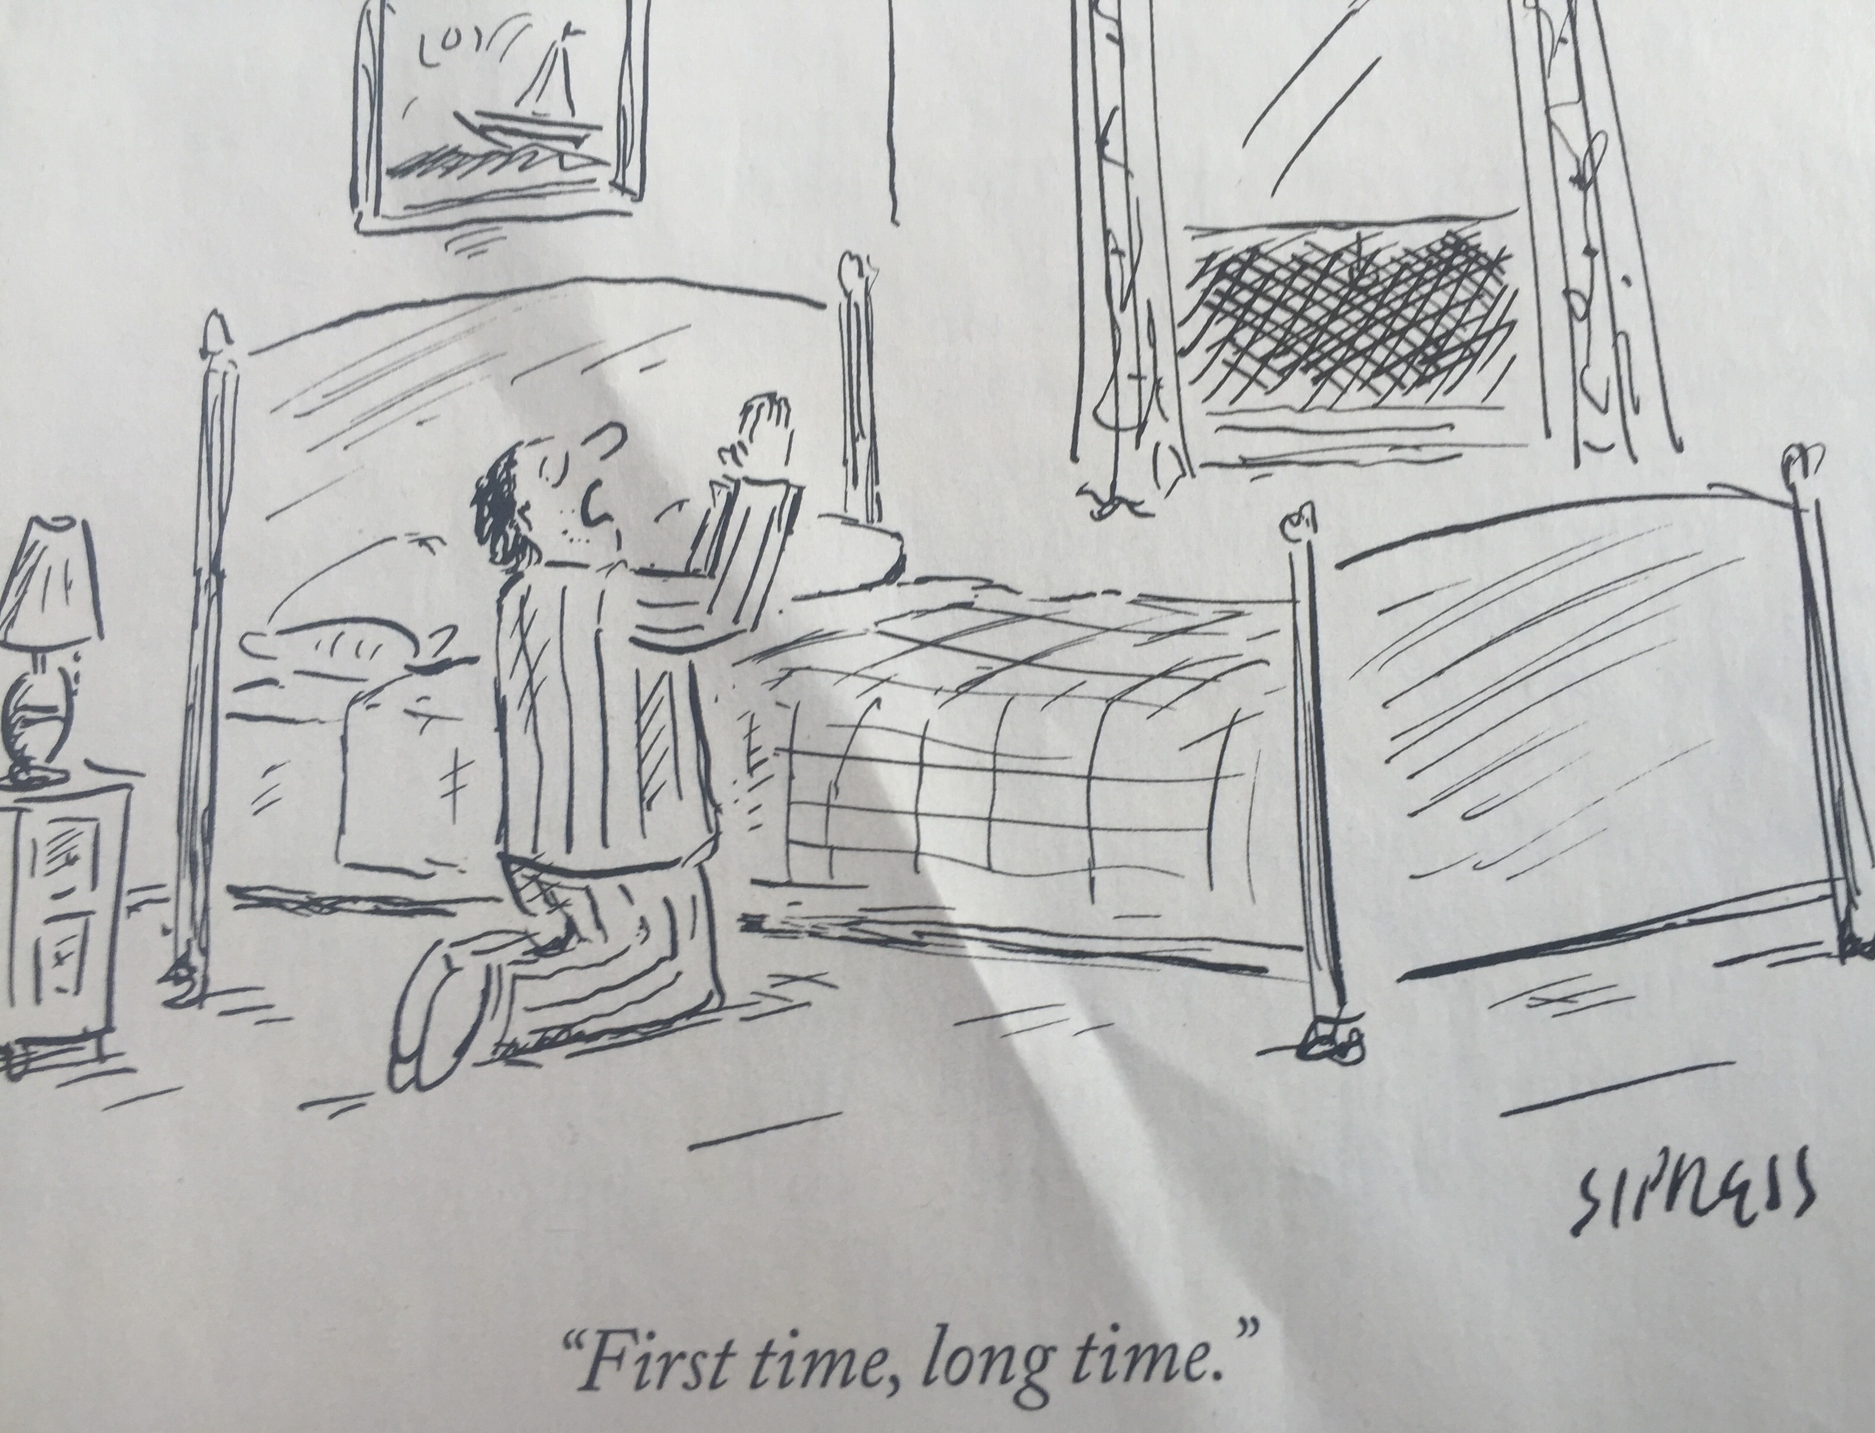
And the next thing you know, we’re getting all selfish with God again—“I, I, I, me, me, me, blah, blah, blah…” And when that prayer becomes a pattern for us, when that’s the only time God hears from us (when our cupboards are bare…), we can start realizing the immaturity of our prayer--and the shame of that realization can become the very thing that keeps us from praying at all. (Do you see that vicious cycle?) Knowing our prayer life should be more than just a 911 call, we allow the embarrassment we feel of always “crying wolf” with God to immobilize us, and so we stop praying…
But there’s a second obstacle, here—one that lies in the distorted image of the God to whom we pray. Because if the embarrassed host in the story is the personification of ourselves in prayer, then the neighbor next door is the personification of how we so often think about God—what we assume must be God’s attitude toward us, right? You see, Jesus is using a contrast, here; he’s describing who God is not. In fact, the way God is described in this story is really rooted in pagan understanding--because if you read literature outside the biblical realm, you discover that indifference sums up the attitude of heaven toward earth. The glory of being a god in pagan thought was not having to worry about humanity, don’t you see… So that somebody who was asleep—somebody totally unconcerned with the problem of an unexpected guest--corresponds exactly to how paganism understood the attitude of heaven.
Jesus is saying that if that’s how we understand and thereby approach God--in almost exclusively negative terms--then we have misunderstood who God really is. Because if God is indifferent to us, then we’re left to harassing and begging, right?--trying to get God’s attention--trying to find something to do that will cause God to care about us. And out of that distortion comes weariness, because we get tired of paging a disinterested God, don’t we… We get tired of paging one of whom we will never really be worthy anyway, so we give up…
Well, fortunately, Jesus does not leave us hanging in the balance, here—does not settle for our weakness and immaturity and distortion. Rather, he tells us to ask and to seek--to knock--that in asking and seeking and knocking we might find. Jesus describes a good father--one who knows what it is to give good gifts to his children--and in the space of just four short verses, he takes on both of our obstacles to prayer. See, Jesus encourages us to do the very thing we’re ashamed of doing--the very thing children are so able to do when they pray—to ask, and to seek, and to knock... Jesus accepts our immaturity for what it is--invites us to start there rather than pretending we’re someplace other than where we are. And then, even more startling, he tells us the kind of Father in Heaven we really have—not somebody we need to nag ‘til we get what we need, but somebody who has always wanted to give us those things in the first place! Really? Really…
And so this morning I want to give you an invitation to pray the Lord’s Prayer again. If you’ve ever become embarrassed or ashamed before God--if you’ve ever gotten the idea that God couldn’t possibly be interested in your petty concerns or lack of faith—then might you receive the invitation of Jesus to pray as he has taught us to pray? Could we do that again—take it slow and let these words wake us up to God, this morning?
Our Father, who art in heaven, hallowed be thy name. Thy kingdom come, thy will be done, on earth as it is in heaven. Give us this day our daily bread, and forgive us our trespasses, as we forgive those who trespass against us. And lead us not into temptation, but deliver us from evil. For thine is the kingdom, and the power, and the glory, forever and ever, Amen.

