March 26, 2017
Psalm 23
Well, we’ve come to the half-way point in our Lenten journey—this season where we’re challenged to live in a way that’s counter-cultural—a way the world we live in just doesn’t understand… It’s a season that moves against busyness—against our human need to be in control—against all those petty loyalties we give ourselves to so readily (like letting the culture define us—define us as consumers--define us by certain political viewpoints--define us by privilege…). During Lent we stop, and wait, and watch, and notice, and listen, and reconsider—in other words, we stop and do what does not come easy for us, right? It’s why the Psalms make such terrific traveling companions—the way they help us on our journey—help us slow down, help us notice, help us listen--help allow God to lead us rather than us leading ourselves... So, we come to the 23rd Psalm--arguably the most beloved Psalm in all the Bible--called the Shepherd’s Psalm… Some of you, I know, memorized this, growing up--don’t even need to look it up--but if you do need to, well, then turn with me to Psalm 23… (read text and pray)
One of the beautiful things about my deal—being married to an elementary school teacher (for 34 years, Julie taught school)—but besides hearing all the hilarious things those children said, it was a joy getting to know them—getting to know third graders--both through their teacher and their parents... It’s how I met the Terpstras--their son Willie having had the life-changing gift of getting Mrs. Healy as his third grade teacher… The Terpstra family was a farming family--raised sheep on their farm—and were kind enough to learn me a few things about raising sheep—about shepherding. Mr. Terpstra grew up in East Africa--lived among shepherds—
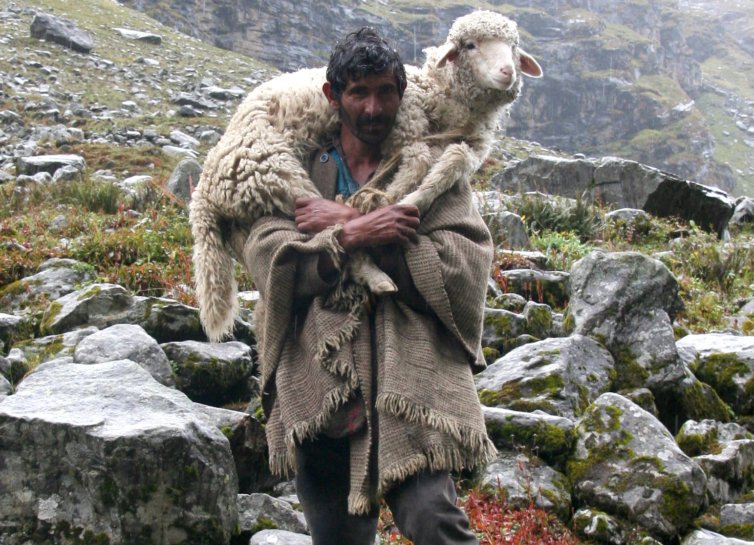
--a lot like those in Bible times—grew up around them and then raised them himself--meaning he knows a thing or three about sheep—knows what a challenge it is. See, shepherds worry a lot, and for good reason—worry about finding places for them to graze—worry about getting them fresh water every day—worry about food in the winter, shelter from storms, protection from predators—worry about disease and parasites... As the old saying goes, a shepherd sleeps with “one eye and both ears open”—gotta be ready at the first sign of trouble…
Shepherds need to be able to get their sheep to lie down—get them to sleep—
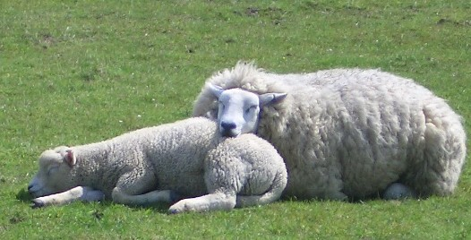
--happens to be a whole lot easier said than done—means:
- the sheep have to be free from all fear,
- means there can’t be any tension between members of the flock,
- means they can’t be aggravated—like, by flies buzzing around or some other disturbance,
- and it means they must be free from hunger…
Which makes them, what?—why, a whole lot like us, right?--those are our sleep requirements! (That and a Sleep Number® bed!) Because if I’m afraid, or in conflict with somebody, or aggravated, or hungry—why, I don’t know about you, but I toss and turn—catch myself raiding the refrigerator at three in the morning! (Can I get a witness!)
Sheep are easily frightened--something as inconsequential as a rabbit jumping out can startle a sheep—cause the rest of the flock to jump right along with them--next thing you know there’s a sheep stampede:
https://www.youtube.com/watch?v=Go3qHTSwUfc
(That’s crazy, right there!) And just like people, sheep don’t always get along with each other--have these petty rivalries--become irritable--take to butting one another’s heads--try maintaining their status as biggest and baddest—get all anxious--lose weight--can’t lie down—can’t sleep from being on their feet all the time--have to defend their territory. And it messes them up, anxiety does… All this neediness--need water, sheep do:
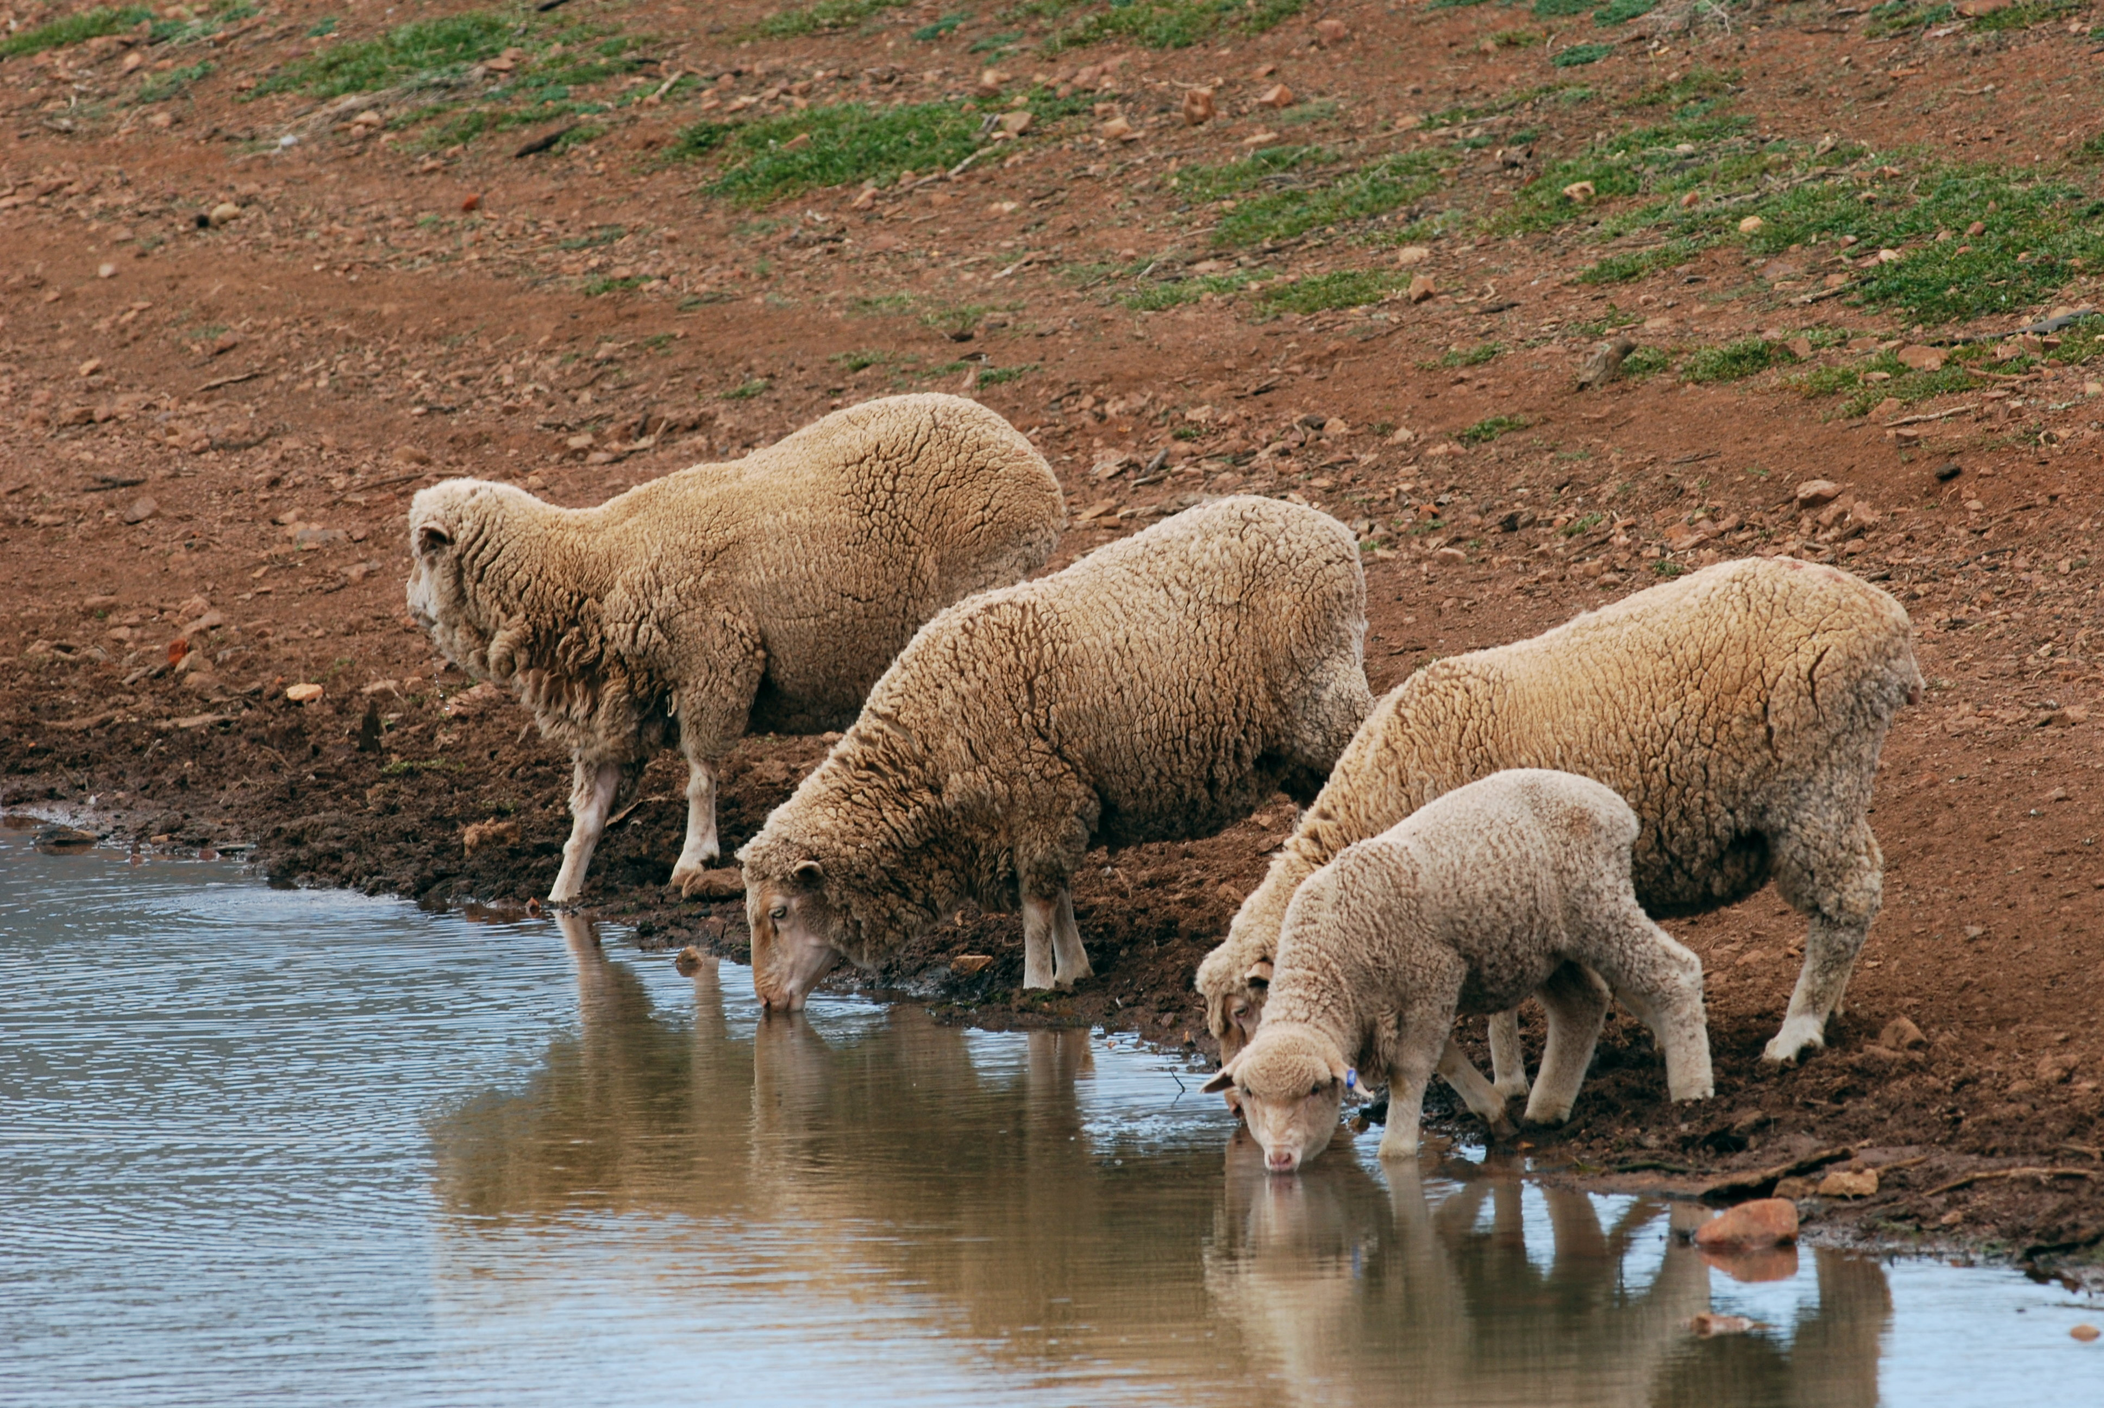
But there’s this curious thing about that--they won’t drink from turbulent water—has to be slow water--like a meandering stream—has to be “still” water—meaning every shepherd worth his or her salt makes it their business to find still water…
And, of course--to add insult to injury--sheep have this miserable sense of direction:
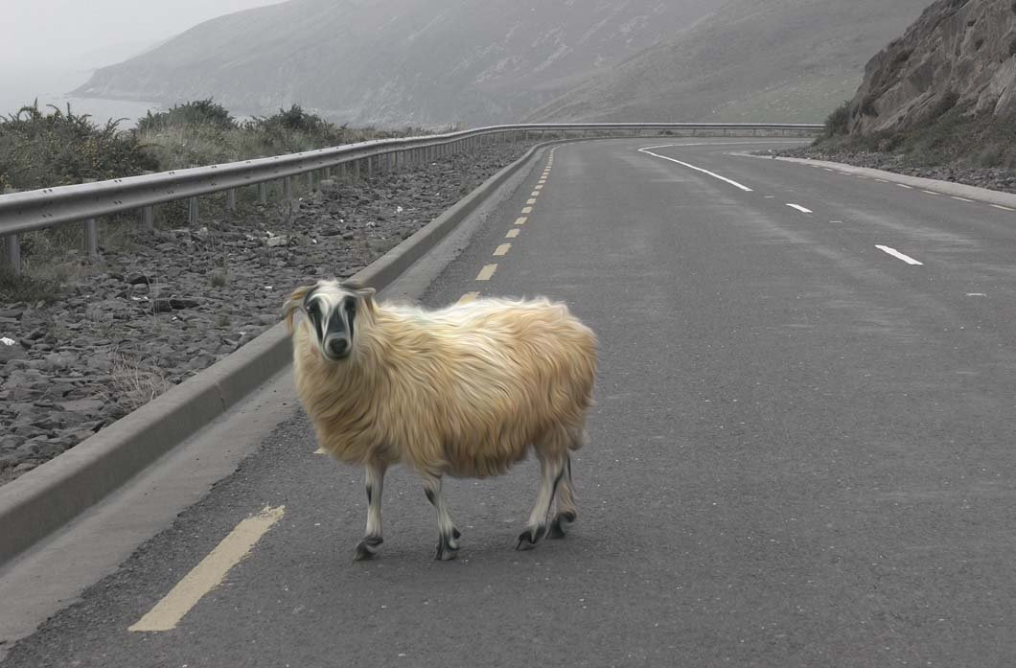
—get all turned around--refuse to ask directions (at least the male ones!) find themselves wandering--getting lost. And worse yet, if they happen to stumble and fall, why, they can’t get back up. (“I’ve fallen and I can’t get up!” they say.) It’s what the old English shepherds would call a “cast” sheep--one that’s fallen--has to just lay there--feet kicking in the air--bleating to beat the band—which is dangerous, because if the shepherd doesn’t show up in time, why, that turned-over sheep will overexert and die… It’s why shepherds search for hours—even days--search high and low for even a single lost sheep:
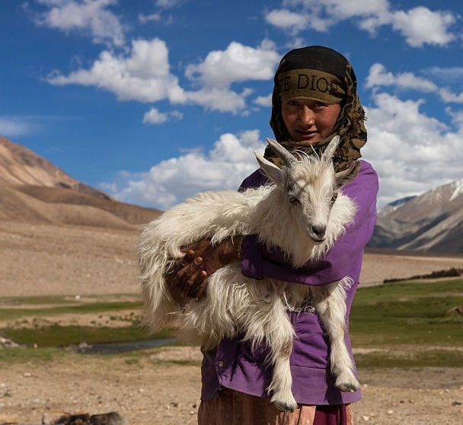
They need to be restored, sheep do--led back again to a safe place--back to the flock. Which happens to be the only way to get a sheep to go someplace—by leading them—because they will not be pushed--they will only be led--will not go anywhere somebody else (namely, their shepherd) hasn’t gone first—in other words, they have to be led down the right path, and for the name’s sake of the shepherd...
So there you have it: Sheep and Shepherding 101...
Now, I’m pretty sure it would not occur to most North American Christians to think of the 23rd Psalm as any kind of rabble-rousing text--as a condemnation of injustice or tyranny. I mean, we hear these words read at funerals, after all--we see them stitched in needlepoint—hear them set to beautiful music--and we’re comforted, right? We don’t hear confrontation--we hear peace, and provision, and tranquility. But try seeing and hearing these words through the eyes and ears of somebody living under the yoke of oppression—try hearing them like somebody whose government claims to care for its subjects, but who’s leaders really are just about exalting themselves. Try hearing that. See, in the ancient world, a king was understood to be a shepherd of the people—had the responsibility of providing them with the resources they needed—and especially providing for those most threatened and vulnerable. It means that when the psalmist opens by saying, “The Lord is my shepherd,” why, it’s an affirmation that God is our king—that God is, for people of faith, our absolute authority, the One to whom we owe our ultimate allegiance. It means that when we pray the Twenty Third we acknowledge a God who exercises royal authority—and who does so in a way that all are able to say, I shall not want. Our God is the source of our food (“green pastures”), our drink (“still waters”), our direction (“right paths”), the source of our very life (a “restored soul”). And God does all that for his name’s sake—that is, in a way that is true to God’s character—because that’s who God is--a Good Shepherd who wills life--who provides what we need to live—what we need to truly live…
And how much we need to hear and know that—especially in a culture like this one—a culture that does not promote or foster humility and gratitude--one that does not invite dependence on God—one that takes aim at making us perpetually dissatisfied with what we have—one that blurs the distinction between “wants” and “needs”—a culture that rewards aggressive self-assertion, and excessive individualism, and rampant greed—the very things this psalm condemns and invites us to reject.
See, I don’t know what kind of shepherd you came to church needing, this morning. Some of you are feeling defined by your situation. Some of you are feeling locked up. Some of you are in hiding, feeling disgraced—you’ve fallen and you can’t get up—can’t get out—can’t get over—you’re in a dark valley—one of your own making or somebody else’s, doesn’t matter—you’ve wandered away—gone hungry—gone thirsty—soul all dried up. But God says, “I’m coming to get you!” God says, “I will stop at nothing to find you!” God says, “You are mine--you were not meant to be lost—not meant to be overcome by any kind of evil, or shame or disgrace—God says, “I got a table for you—I got goodness and mercy ahead for you—I got an overflowing cup for you—I’ve got a dwelling place for you!” Because the 23rd Psalm is not messing around…
I mean, is somebody here, this morning, who has come though some kind of dark valley? Some disease? Some time when you were lost? You see what coulda happened—you see what shoulda happened—you don’t even know how you got out—but some kinda way God brought you out—God made a way where there was no way—and you are here to praise Almighty God for that! It’s called a testimony. And I can’t tell you the number of people, even in the last two weeks, who have been given a testimony--and they’ve told me. And nothing but nothing encourages my spirit like hearing a testimony. So, Thursday evening--I’m about to make my way home from Park--and I wander into Martial’s office. I said, “I think we need a testimony on Sunday--one in song.” And Martial agreed. (I love it when Martial agrees with me!) So there was some brooding on that idea--and prayer--and Rachael accepted the invitation…

Along with the writings of Phillip Keller, who wrote A Shepherd looks at Psalm 23, Zondervan: 1970.

