Sermon: Pastor Will Healy
September 22, 2019; Luke 16:1-13
Well, we’ve come, this morning, to what many people think is the most difficult parable in the Bible--sometimes called The Parable of the Dishonest Manager (which almost sounds like a Perry Mason episode… And, for those of you younger, Perry Mason was a TV show, back in the day--back when television was only in black and white and we had just 5 stations--to change the channel you actually had to get up from the couch and turn this thing called a dial… Ask your grandparents!) But history tells us this story about a dishonest manager from Luke’s gospel has, more than any other, been used to try and discredit the Christian faith. The 4th Century Roman emperor, Julian the Apostate, said this text was evidence that Jesus came to offer a “religion of scoundrels.” It’s been called a “notorious puzzle,” a text that has produced mountains of explanations, each of them more confusing than the last. Because what do you do with a story like this—one that seems to compliment dishonesty? How do we handle a teaching that seems to so clearly imply that the end always justifies the means?
Because that’s what happens in the parable, right? This rich landowner discovers that the guy he hired to be his business administrator has been mismanaging the company’s assets--squandering his fortunes. The “books are being cooked.” And so into his office the administrator is hauled, and the owner is livid: Don’t think for a minute that I’m not on to you, he says. I want a complete audit. Furthermore, you’d best get yourself a good lawyer, because you’re out of a job. I. have. had. enough!
And so like any of us caught with our hand in the cookie jar, the administrator begins shaking in his boots. Lacking the physical stamina to do physical labor--to do a real job--and too proud to humble himself to stand on the street and beg--he hatches a plan. Figuring he’s got nothing left to lose, he begins cutting deals. Anybody who owed the boss gets an offer to slash their debt, sometimes by as much as fifty percent. Before word’[s even gotten out that he’s been pink slipped, he’s out to make as many friends as he can, a kind of hedge against this perilous future coming his way. And what an ingenious plan, right? I mean, before you get thrown out on the street, why not get a few folks in your debt--curry a few favors--scratch a few backs--make a few offers people can’t refuse? Maybe it will come in handy down the road, when the going gets tough…
It is cheating, don’t you see—cheating his boss out of even more than he has already cheated him. And here’s the shocking thing--that when the owner finds out, rather than having this rogue thrown into jail (or into the river in a pair of cement overshoes), the boss actually praises him. He says, “You know, being a bit streetwise ain’t all bad. It’s time people stopped being so naïve about how the world works--got up to speed. Time for a little shrewdness. Well played!”
But then we read the verse that makes our skin crawl (verse 9): “I tell you,” Jesus says, “make friends for yourselves by means of dishonest wealth, so that when it is gone, they may welcome you into the eternal homes.” In other words, don’t let a little thing like honesty stand in the way of your shrewdness. The end justifies the means, right? You see the dilemma here--the conundrum? Surely Jesus must have been misquoted, taken out of context--must be some mistake…
You see, most of us (at some point in our learning experience), have been taught the opposite of what appears to be the deal, here, right?—been taught that the end does not justify the means--that it’s not simply a matter of whether you win or how much you accomplish or how high up the corporate ladder you ultimately climb. To the contrary, it is a matter of how you manage to arrive at those places. To win by cheating is no victory (as the ongoing PED scandals in sports and the Wall Street and political abuses remind us--almost daily!); to gain the whole world but lose your soul in the process is no accomplishment. Yet as Pontius Pilate found out, even the soap in the executive washroom can’t take the stain out of an unprincipled rise to the top.
So, there must be some mistake. Otherwise, we’re left with a teaching that runs contrary to the very ethic we embrace as the followers of Jesus. It’s who we most understand him to be—one who refused to employ unjust means to get his way--one who allowed a profound injustice to be done to him--that we might experience salvation from our sins. So how to make sense of this text?
Well, there’s a principle I’ve found to be essential in our understanding of the parables of Jesus--a principle I turn to in moments like this. It’s the guiding principle of parabolic interpretation--that Jesus taught in parables to (almost all the time) get across one, main point. In fact, it’s when we try to make the parables say more than they were intended to say that we get in trouble. Because the point Jesus is making, here, is simple: God’s people sometimes need to be shrewd. (I’ll say that again: “God’s people sometimes need to be shrewd.) We live in a big, complicated, sometimes mean world, and if we hope to make it through, we’re going to have to keep our wits about us. God has given us minds--he wants us to use those minds to take care of ourselves--to employ the very best of our thinking in navigating the tricky, often dangerous waters of human experience. I like how my mentor Eugene Peterson paraphrases this verse in The Message. He says: Streetwise people are on constant alert, looking for angles, surviving by their wits. I want you to be smart in the same way (Jesus is saying)—but for what is right—using every adversity to stimulate you to creative survival, to concentrate your attention on the bare essentials, so you will live, really live, and not just complacently get by on (your ) good behavior.
Do you see the virtue in that? God does not want us to be naïve--to be un-hip to how the world works--so that we get devoured out there. So, the message goes: Get shrewd. Do not keep letting others get the best of you. Do not be a pushover, a doormat, over which others run roughshod. Sharpen up your discernment--your acumen--so that you don’t keep getting the wool pulled over your eyes--keep getting taken advantage of.
Now, I don’t know about you, but no sooner do those words come out of my mouth than the red flags start popping for me. Because shrewdness, in my experience of the world, so easily slips into greed--into dishonesty and the exploitation of people. Politicians try being shrewd and what happens? Next thing you know, they’re crossing the line, breaking the law, creating enormous messes to clean up after. Shrewdness seems to lead to the notion that we are somehow above the law, and so much damage gets done. Which is why the next few verses in our text become so hugely important in applying this parable to our lives—so important.
You see, if there’s one thing Jesus understood about us, it’s that we need a system of checks and balances as we move through the world. Left to our own devices--with no means of being held accountable--we wander into the meanness of this world and end up living lives that fail to honor God. We succumb to the temptation of power, and greed, and violate the very ethics of our calling as God’s people. And so we need to read on--need to discover these two essential safeguards Jesus provides—safeguards to keep our shrewdness in check. And the first is found in verses ten, eleven and twelve. Jesus says it is not how much we have that’s important; rather, what matters to God is how we manage what we have. Which is something the culture we live in doesn’t have a clue about.
See, we live in a world trying to convince us--at every turn--that it’s size and prestige and amount that matters (as opposed to humility--as opposed to an understanding of being a steward of God’s creation). What was that story I heard the other day—the one about the CEO of a Fortune 500 company who pulled into a gas station one day, and after paying his bill inside he came out to find his wife in a deep discussion with the service station attendant. As it turns out, she knew him. In fact, back in high school, before she met her eventual husband, she used to date this guy. Well, the CEO got in the car and the two of them drove in silence for a bit. He was feeling pretty good about himself--more than a little smug--when he said: “I bet I know what you were thinking,” he said. “I bet you were thinking you’re glad you married me, a Fortune 500 CEO, and not him, a gas station attendant.” “No,” his wife replied, “I was thinking if I’d married him, he’d be a Fortune 500 CEO and you’d be a gas station attendant.”
In a world so misguided about what success is, and with such an impoverished understanding of stewardship, how much we need this God-given corrective to the excesses of our culture, excesses that cause so much pain and confusion and bondage for so many…
Called to be stewards of what we’ve been given, and then, too, reminded that it is impossible to serve two masters. That’s the note on which Jesus ends his message, here. He makes it clear: God and wealth are mutually exclusive objects of our devotion. And if we try straddling that fence, like any fence, it’ll hurt.
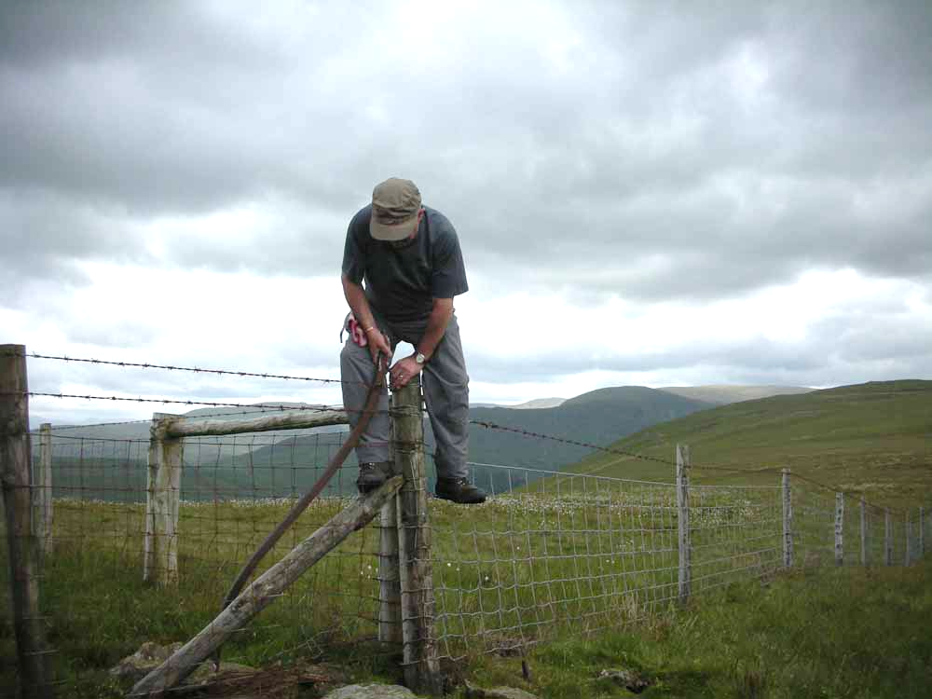
It’s something we so easily deceive ourselves about, this caution--fall into the trap of comparing ourselves to others rather than looking to become our own best selves. It’s a trap, wealth is--one Jeus doesn’t want us falling into. And what I’ve told my children (and what I try to remember to tell myself), is that if you want to keep from falling in, give more away. It might just be the shrewdest thing you’ll ever do, that... You give it away and it loses its grip on you, and we begin to discover contentment with what we do have rather than discontentment with what we don’t...
The good news of the gospel is that we have a God who wants what’s best for us. Maybe you’re here this morning and there is a need for a measure of shrewdness in your life. Maybe you’re in a less-than-healthy relationship, or maybe it’s in your financial life, your professional life. Maybe you’re at that place of trying to choose what to do and you know you can’t afford to be naïve about things any more. Jesus wants us to know that as we step out into those challenging waters, he will give us the guidance and the safeguards we need to exercise shrewdness wisely, in a way that furthers the good we’ve been called to further.

